**KIYALA HIGH SCHOOL**

**END OF TERM ONE ASSESSMENT TEST -2024**

**HISTORY AND POLITICAL EDUCATION**

**Paper 1**

**S.3**

**2 Hours**

**INSTRUCTIONS**

* This paper consists of two sections **A** and **B**. It has ***four***examination items.
* Section **A** is ***compulsory***.
* Answer **one** item from section **B**
* Any additional item answered will not be ***scored***

**SECTION A**

*Attempt* **all****the items** *in this section*

**Item 1**

African societies in precolonial economy had developed traditional hand crafts industries which produced commodities to satisfy their demands. This included back cloth making, basket weaving, black smiting and many more others.

The ministry of education and sports has organized a cultural gala slotted to take place on the 25th, 04, 2024 and will be hosted by Kiyala High School. The main topic of the gala will be ***“The traditional cultural handcraft talent show”*** where by the guest of honour will be the right Hon. Speaker of parliament **Among Anita**

***Task***

As the head prefect of Kiyala High School the host, you have been requested to make a speech to the audience and also representing the students body of the various schools that have attended the event.

Write a speech based on the topic of discussion ***“The traditional cultural handcraft talent show.” (10 scores)***

**Item 2**

Consider yourself as a famous historian in your community and you get a chance to certify the consequences of the scramble for and partition of Africa to the form three (3) students.

***Task***

Giving examples, ***Define*** the term scramble for and partition of Africa and ***giving*** explanation, identify ***eight (8) reasons*** basing on the above statement. ***(10 scores)***

**SECTION B**

*Attempt* **only one** *item from this section*

**Item 3**

**In 2020-2021** Budget, the Kampala Capital City Authority Set up 9 billion shillings to

punch up the potholes on different city roads. The Minister for Kampala Betty Amongi told

the Journalists at Uganda Media center that they had seeked permission from the Minister

of Finance to have all the meant for infrastructures works that were dedicated to the

emergency road repairs. Betty Amongi said that 38 roads, 8 were in Rubaga division, 5 in

Nakawa division, 8 in Makindye division including salaama road which is in bad condition,

8 in Kawempe division and 9 roads in central division were to be worked on.

**Unfortunately**, in **2020-2021** Budget the Minister of Finance Matia Kasaijja told the

parliament committee that the money meant for repairing these roads was not there. The

parliamentary committee chairperson was shocked with his members on the committee.

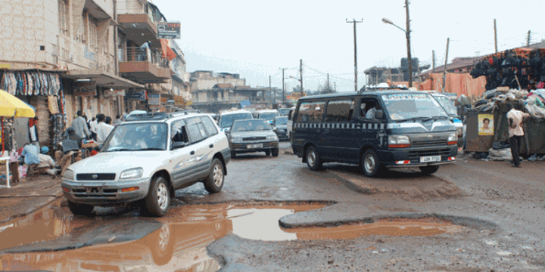

**Task**

1. Why do you think the Government of Uganda prioritizes the road construction and

maintenance through better allocation of funds in the budget? ***(08 scores)***

1. Explain the challenges faced in the road maintenance in your country? ***(07 scores)***

**Item 4**

The Africans were drown into the participation of the second world war of 1939-1945 which was of **No** interests to them.

***Task***

As a historian from east Africa, identify ***eight (8)*** reasons to show how the Africans became the victims of this war. ***(10 scores)***

**END**